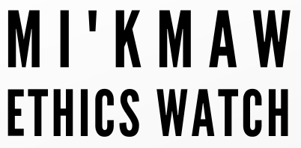
AMENDMENT FORM

MI’KMAW RESEARCH PRINCIPLES AND PROTOCOLS:
CONDUCTING RESEARCH WITH AND/OR AMONG MI’KMAW PEOPLE

This form should be completed to request a change to a study that was previously approved by Mi’kmaw Ethics Watch.

STUDY INFORMATION
Study information
Title of Study
Applicant name
Institutional/ organizational
affiliation(s)
Email |  | Phone
Co-Applications or Collaborators
Contact information for co-applicants and/or collaborators
Community/communities name and contact person
Date Approved by MEW | DD/MM/YYYY

AMEDNMENT(S) REQUESTED
Indicate below the changes that will be made to your study. Append all associated documentation.
In the box below, briefly explain the proposed changes and the reasons for them.
Click or tap here to enter text.
Change of researcher(s), collaborator(s), or communit(ies) | ☐Yes  ☐N/A | Click or tap here to enter text.
Change to recruitment | ☐Yes  ☐ N/A | Click or tap here to enter text.
Change to informed consent procedures, forms, or scripts | ☐Yes  ☐ N/A | Click or tap here to enter text.
Change to design or methods | ☐Yes  ☐ N/A | Click or tap here to enter text.
Change of funding | ☐Yes  ☐ N/A | Click or tap here to enter text.
Extension past anticipated end date | ☐Yes  ☐ N/A | Click or tap here to enter text.
Change or copyright, royalties or community engagement | ☐Yes  ☐ N/A | Click or tap here to enter text.
Other | ☐Yes  ☐ N/A | Click or tap here to enter text.

PLEASE ENSURE ALL NEW DOCUMENTATION IS INCLUDED WITH THIS ADMENDMENT FORM (QUESTIONNAIRES, CONSENT FORMS, ETC).
THE COMPLETED FORMS SHOULD BE SENT ELECTRONICALLY TO:
MEW@CBU.CA

